|  |  |
| --- | --- |
| Project Name: | HRAS |
| Test Case Number: | 3.8-2 |
| Brief description: | Clicking “no” button for a suggested symptom |
| Relevant section of spec doc: | 3.8 |

Input Assumptions:

Relevant state of DB: Import files have been loaded into the DB.

Also assuming the SQL query:

“select * from [Symptom] where [SymptomName] = 'Excessive Reflection'

”

Returns 1 row. Also the query:

“select * from [Visit]”

Should return the top two results in image below:

“select * from [Symptom]”

Should return the bottom two results in image below:

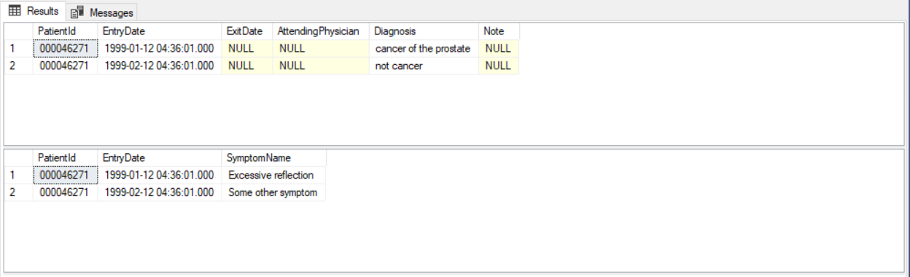

Finally, the query:

“select * from [User] where [Username] = 'test' AND [Password] = '123' AND [UserType] = 0”

Returns 1 row.

Other relevant environmental assumptions (if any): (system config, etc.)

User Actions:

1. Enter Username “test” into username input field.
2. Enter Password “123” into password input field.
3. Click “Login” (You should now have entered the Main Menu, you can alternatively get here by “bypass login button” in testing).
4. Click “Search Patient” button.
5. Enter “t” into first name input field.
6. Select User with First Name “Tabitha” and last name “Bennett”.
7. Click submit.
8. Click “Diagnosis Wizard” button, the Diagnosis wizard page should open with suggested symptom “Excessive reflection”.
9. Click “No” button.
10. Click “Add Results to Patient Record” button.

Expected Results:  
The user should be brought back to the “Patient Record” as in the SRS Document in section 3.5.

The “diagnosis” field should have value “not cancer” (as the visit with diagnosis “cancer of the prostate” **has** symptom “Excessive reflection”. However, the visit with diagnosis “not cancer” **does not have** symptom “Excessive reflection”).

Actual Result:

(Not possible yet as this page is currently under development).

Result matches expected result? Yes  No

If not then, fill out the information below:

|  |  |
| --- | --- |
| Defect Report Number: |  |
| Assigned to: |  |